CPNM Lab Assignment Day 4

# Arrays and Strings

Date – 22-12-2022

1. Write a program which takes some numbers and computes the standard deviation of them using functions. 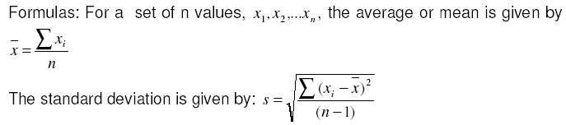

Example:

Enter 10 numbers:

10

12

23

23

16

23

21

16

14

11

Standard Deviation: 5.2164270445499

1. Write a C program to find the biggest number in an array using an user defined *recursive function*.

Enter 10 numbers:

10

12

23

25

16

-8

21

0

14

11

Biggest Number: 25

1. Write a program for accepting values in two square matrices of 3x3 dimension and generate their sum, difference and product of both the matrices. Create three different user defined functions for each of the operations.

Example:

Enter values for matrix 1:

1 2 3

4 7 8

2 4 1

Enter values for matrix 2:

5 5 8

2 6 9

3 1 2

Sum:

6 7 11

6 13 17

5 5 3

Difference:

-4 -3 -5

2 1 -1

-1 3 -1

Product:

18 20 32

58 70 111

21 35 54

1. Write a C program which accepts a string from user and
   1. Counts the number of characters in the string. [Compulsory]
   2. Counts the total number of words in the given string. [Compulsory]
   3. Prints the reverse of the string. [Compulsory]
   4. Finds the most frequent character in a string. [OPTIONAL]

*String library functions cannot be used anywhere.*

Example:

Enter string:

Jadavpur University

Characters: 19

Words: 2

Reversed: ytisrevinU rupvadaJ

Most frequent character: a,i,r,u,v

1. Write a C Program to enter a string and find the histogram of alphabets for that string. Histogram means the number of occurrences of each alphabet in the string. *String library functions cannot be used anywhere.*  
   Example:

Enter string: Mississippi

i: 4

m: 1

p: 2

s: 4

1. Write a menu driven C program that converts a string like “123” to integer 123 and vice-versa. Do not use any string library function. Use two separate user defined functions that return appropriate results.

Example:

Press 1 to convert string to integer

Press 2 to convert integer to string

Press 0 to quit

1

1234

Number: 1234

Press 1 to convert string to integer

Press 2 to convert integer to string

Press 0 to quit

2

560

String: 560

Press 1 to convert string to integer

Press 2 to convert integer to string

Press 0 to quit

0

1. Write a function squeeze(s,c) which removes all occurrences of the character c from the string s. There should be no blank space in place of the removed character. [OPTIONAL]

Example -

Enter string: hello students, welcome to computer science.

Enter character: o

Output: hell students, welcme t cmputer science